Anveshane

……a journey to experience the nature

Anveshane is aimed to create meaningful outdoor experiences which stimulate and motivate the participants to learn through exploration and experiences. Participants will be exposed to natural habitations, areas of rich biodiversity, human settlements, agricultural fields, ex-situ conservation sites, parks and interpretation centers to understand the linkages between nature and human life. Socio economic and environmental issues will be interwoven in the content of program so that the participants will get the holistic view of issues related to development and conservation.

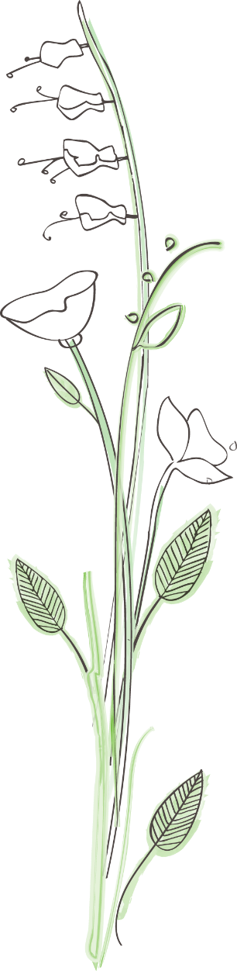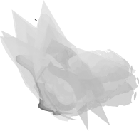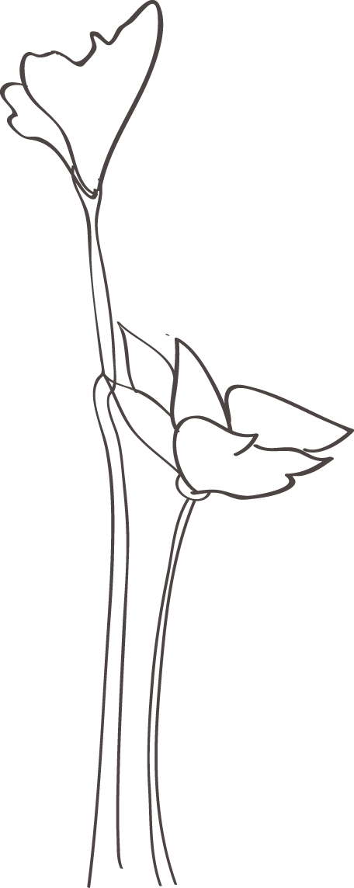

**Who can participate?**

Anybody who has keen interest to learn about environment and commitment for conservation actions can be part of our camps. Teachers, students (school-colleges), professionals, youth groups, wildlife lovers, or those who like adventure explorations can participate in our program. We will try to design the program based on the interest and expectations of the participants. For example, one group of teachers may request us to focus more on approaches and methodologies of teaching environmental related concepts in classroom through outdoor education initiatives, others may wish adventurous camps. However the present program is designed to cater groups of heterogeneous interests.

**Our motto?**

To reach as many as possible to make them feel the nature by being with nature.

The basic objective of this program is to,

* Provide firsthand experience of environment
* Trigger the interest to explore their immediate habitat
* Enhance one’s appreciation about the nature and sensitize to take up small actions leading to conservation of nature and natural resources

**What you can expect from us …………?**

At these programs participants will be sensitized about oneself as well as their immediate environment. This outdoor initiative will provide enough opportunities and experiences through which participants can adapt to environment friendly habits and life styles. The activities demonstrated in these programs and education kit provided can be used to educate the peer groups around. Students can link these activities to their respective syllabi. Teachers can pick up bunch of techniques to deal with their classroom challenges.

Apart from mere out door program it also indirectly caters to other relevant corners of life. The participants are taught by the experiences they get during these programs which involve team building, leadership, communication, coping with difficult situations, decision making, dignity of labour, teaching and learning techniques etc. It certainly influences their way of thinking, their habits, their behavior towards nature and natural resources.

**How we interact with you ?**

The various teaching-learning approaches of this program involves formal and informal discussions, lectures, demonstrations, field trips, nature trial, trekking, wildlife/insect/bird watching, documenting the habitat status, interviews with conservationists, interactions with community, discussions on issues related to conservation and development, film shows, informal education approaches like skit, puppet, craft and arts altogether helps us to understand the basics of environment, conservation to multi-dimensional concepts like climate change, sustainable development etc.

The program is not tailor made to suit any particular group but content and approach will be modified according to the group’s interest and need. Before setting the tone the schedule will be discussed with the participants and finalized.

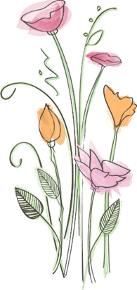**Our approach - Learn with Fun**

The activities of this program will help participants to ease themselves by involving in fun filled activities and transforming the experiences in to long lasting leanings. The topics vary from social, environmental to developmental issues. The broad topics of environmental concerns will be covered in general and topics with specific interests such as making bird nests, herbaria preparation, insect collection, conducting awareness campaigns etc., will also be discussed with the interested individuals or the group.

**Through this program we will ….**

* Provide an opportunity to explore and experience nature
* Connect abstract scientific ideas with ‘hands-on’ experiences
* Make participants feel that they are part of a greater ecosystem
* Promote development of holistic personality in turn to promote responsible citizenship
* Understand ones interests and build right attitude to promote conservation spirit
* Instill the basic elements of personality development of one self and enhance interpersonal dimensions



**What we expect from participants**

Interest to learn, Interest to share and Commitment to act

**Nature of activities**

1. **Nature camp** – Normally 3 days and two nights in selected protected areas of Karnataka ( Nagarahole, Bandipur, Dandeli, Muthodi, etc,) based on the availability.
2. **Wild circuit** – A journey to different eco systems and learning centers (more than two days)
3. **Orientation workshops** – in nearby forest camp sites - (One day or Two day one night )

**Target Groups**

* Teachers
* Teacher trainers
* Students

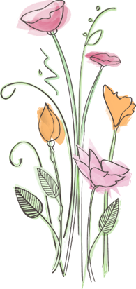

**Activities planned during the Anveshane………**

Nature trial- Small trekking-Demonstrations

Nature games and activities

Study of ecosystems

Bird watching / butterfly watching / identifying plants, insects etc

Visit to Museum and Zoo

Interaction with experts

Sessions on Outdoor education

Wildlife / environment related movie screening

Slide shows followed by discussions

Co-curricular and extracurricular activities

Campfire - Group activities - Fun games

**Detailed Schedule will be provided based on the nature of activity required**

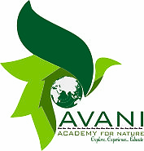

**Introduction to Avani Academy for Nature**

Avani Academy for Nature is engaged in developing programs and materials to increase awareness and concern, leading to action, regarding the environment and sustainable development. Academy came in existence in the year 2017, as an implementing agency of larger group, Wildlife Aware Nature Club Tumkur dedicated to cause of wildlife and conservation since 1990.

Academy caters to conservation needs and working with a bandwidth of stakeholders from children to policy makers. It has designed, developed and implemented innovative programs to cater the needs of different target groups. Outdoor education is one such approach towards reaching students teachers and other interested groups to make conservation education more interesting and effective. Anveshane - Basic orientation to ecology; Anubhava - Nature walk and trekking; Adhyayana – Projects on wildlife and ecology.

**Core purpose**

Purpose is to create platforms for collaborative learning and to promote sustainable practices, help education institutes to bridge theoretical and practical knowledge, encourage youths and community to participate in conservation movement

**Thrust areas**

* 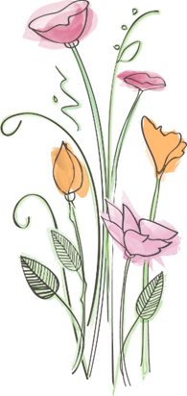Explore – journey to untraversed areas of knowledge
* Experience –hands on experiences to feel and understand nature
* Educate –activities to promote green thinking and to create green mind set.

**Some of the programs we are doing for students and general public are;**

* Heritage walk in Devarayanadurga State Forest
* Day with Butterflies, Birds, Reptiles – lifecycle journey
* Walk on the banks of tanks– migratory birds
* Wilderness in Tumkur – visit to wild habitats
* Explore and experience nature – Camping

*Contact : Dr. D.R.Prasanna Kumar – 9880196633,*

*Dr. G.S.Mahesh – 9448132004, Mr.Mallikarjun – 9886385549 ; [avaniacademy.nature@gmail.com](mailto:avaniacademy.nature@gmail.com)*